# **The ChapR**

## What is the ChapR?

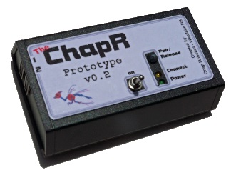The ChapR is a Bluetooth remote control that connects to the NXT (brain) of a robot that has been programmed with RobotC. Once connected to the NXT, the ChapR can control the robot by feeding it commands from the joysticks that are plugged into the ChapR.  The ChapR is a replacement for using an expensive laptop and software to control the robot.  It helps teams with limited resources be more successful with their robotics programs.

## Who are we?

We’re a group of Westlake High sophomores. We are members of Chap Robotics, the high school robotics team. Chap Robotics competes in several competitions, including the First Tech Challenge (FTC) and First Robotics Competition (FRC).

## Why are we applying for help?

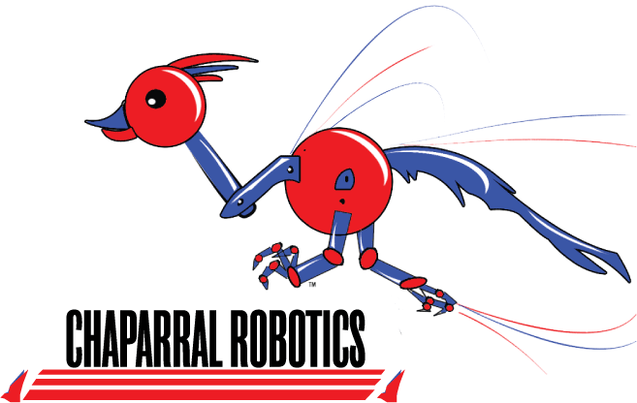As a student-run project, we have very little capital to produce the initial ChapRs. Once we have sold a few ChapRs, we will have funds to begin producing more. Our customers pay $100 dollars for a ChapR, unless they cannot afford one. Those who cannot afford one can apply for a free one on our website. The ChapR only costs about $75 to produce, so we make a $25 dollar profit, allowing every three purchases to provide a free ChapR to a team in need.

## Our Mission

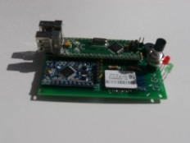Provide a ChapR to every team that wants one, even if they can’t afford it. We hope to eventually have a ChapR in the hands of every FTC team across the country.

## For more information contact:

Student Leader - Rachel Gardner ([rachelgardner9@gmail.com](mailto:rachelgardner9@gmail.com))

Mentor - Eric Rothfus ([eric@rothfus.com](mailto:eric@rothfus.com))

Westlake Robotics Coach - Norman Morgan (nmorgan@eanesisd.net)

## Website:

www.TheChapR.com